VIETNAM NATIONAL UNIVERSITY, HO CHI MINH CITY

UNIVERSITY OF TECHNOLOGY

FACULTY OF COMPUTER SCIENCE AND ENGINEERING



# Software Project Management

**(CO3012)** **LAB 5**

Instructor: Mai Duc Trung

Students: Trịnh Công Vũ - 1852882

1. **Report related to the project itself**

MS Project support many types of report, simply go to the **Report** tab:

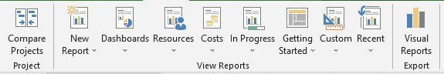

**Cost:**

•

Cash flow

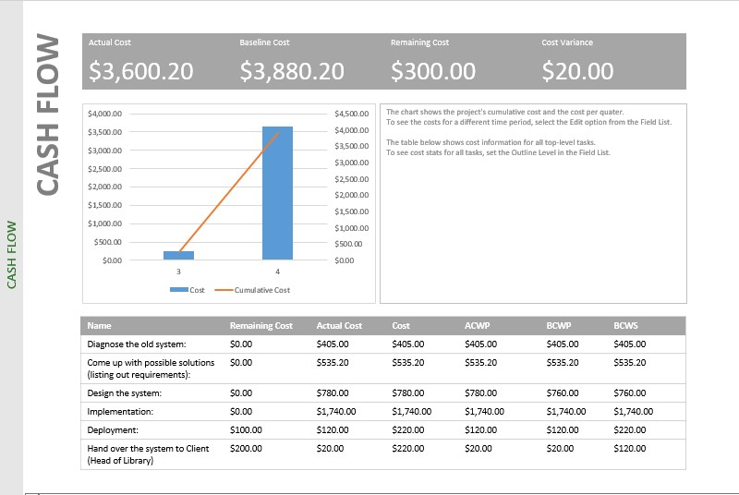

• Cost overruns

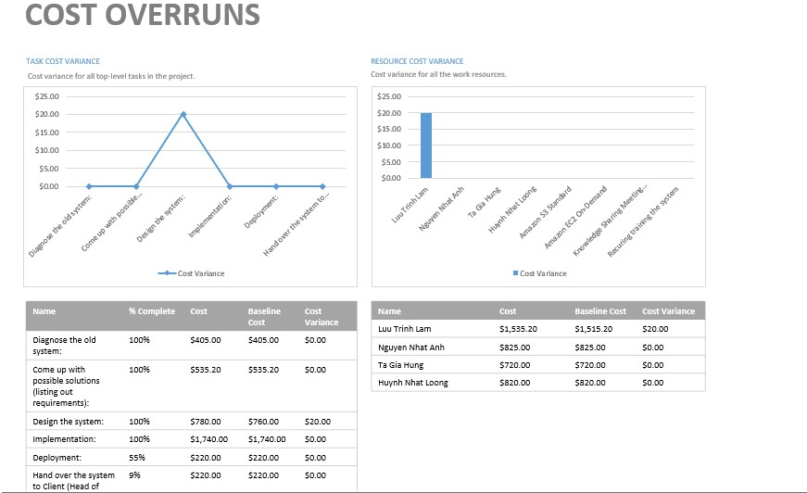

•

Task cost

overview:

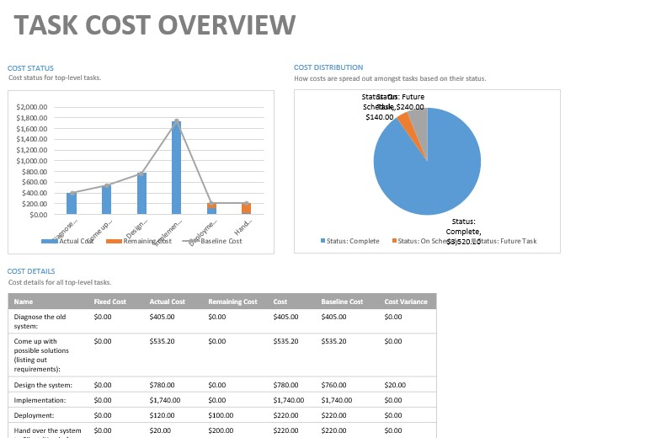

**Resource usage:**

•

Resource overview:

•

Over

-

allocated resource:

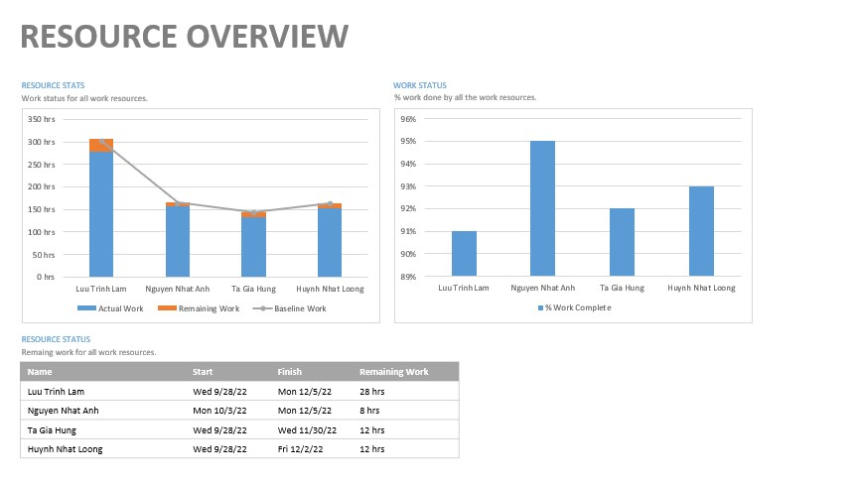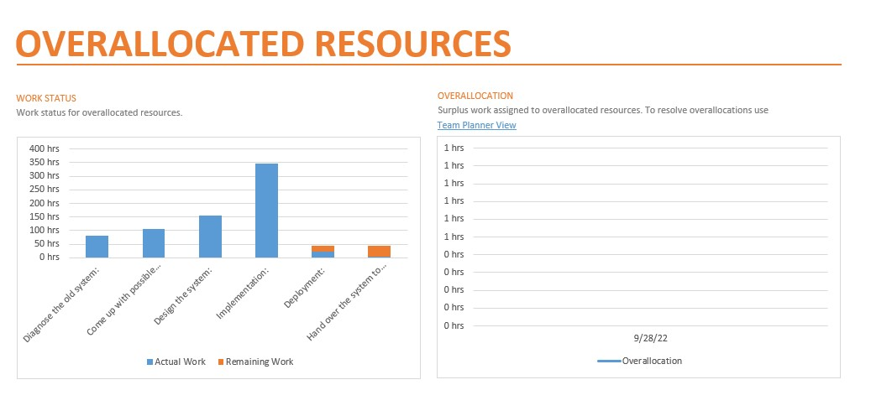

**Work of the project:**

•

Critical tasks:

•

Late task:

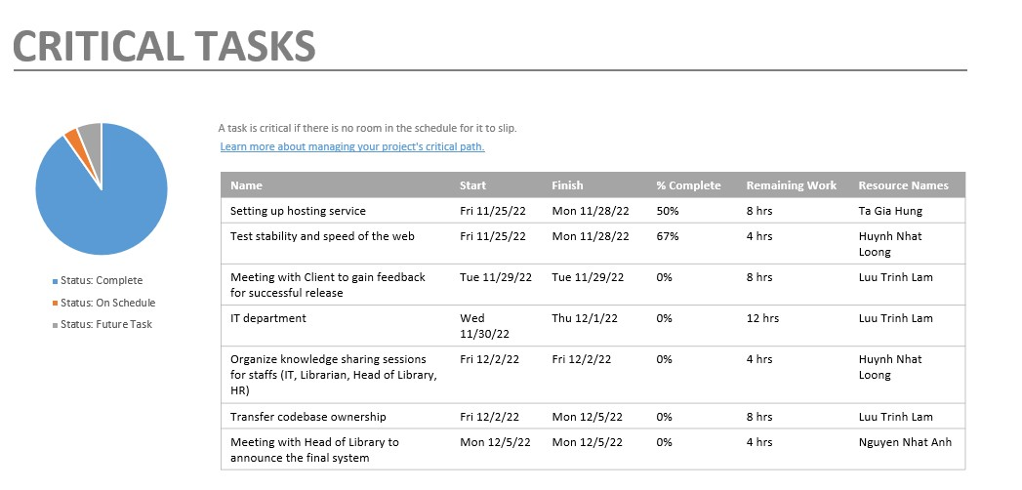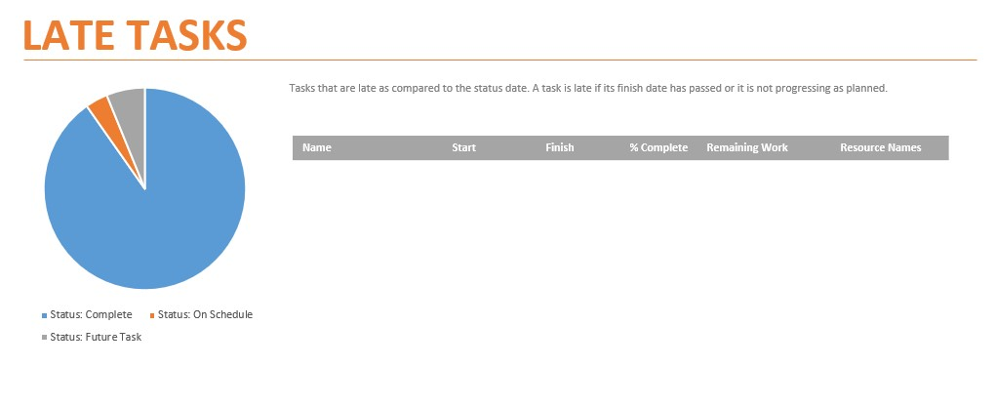

1. Printing and exported types of report

We can print the entire project / specific date / specific page if we want:

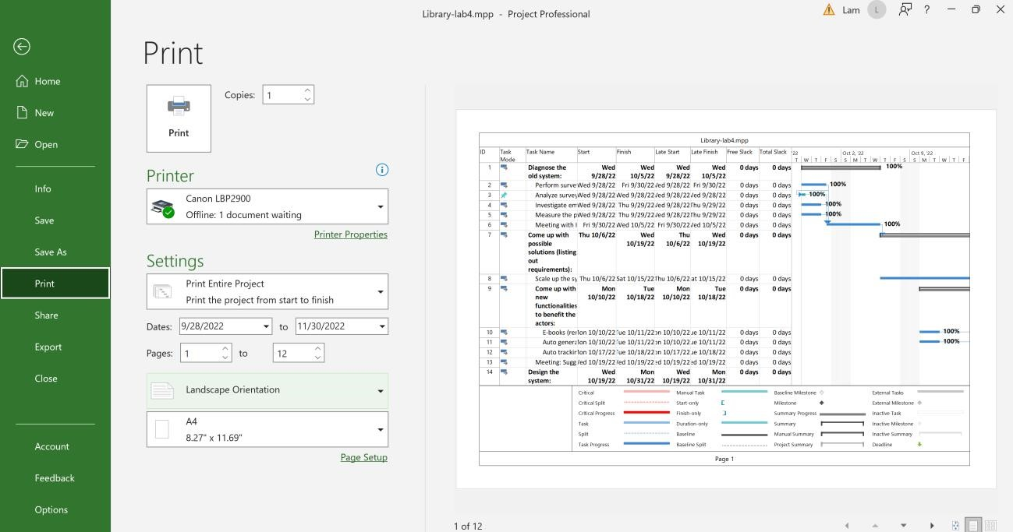

With many options:

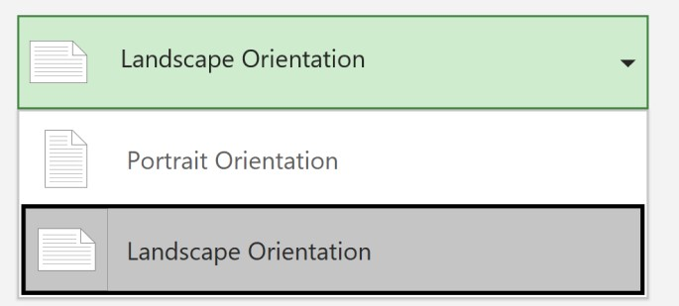

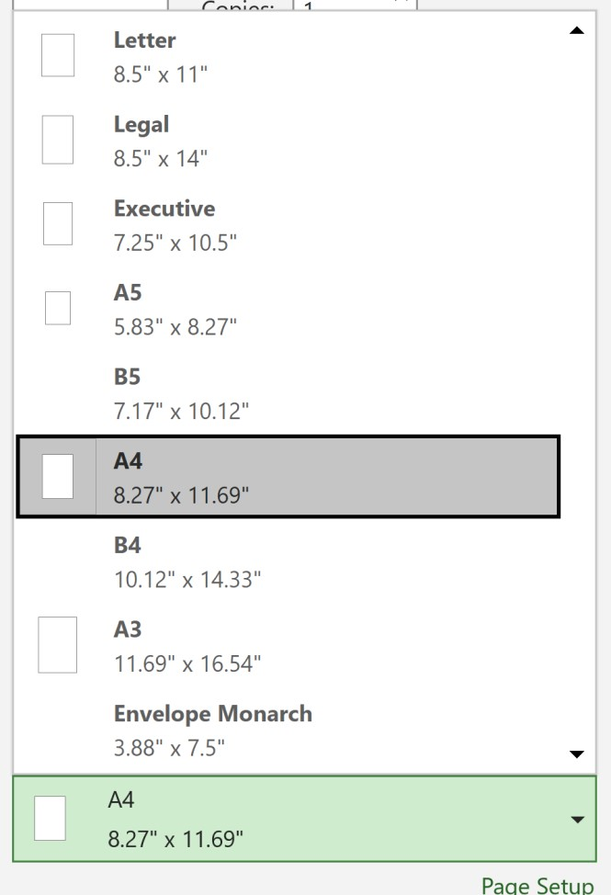

In addition, we can also export the project in the extension that we want using **Save As:**

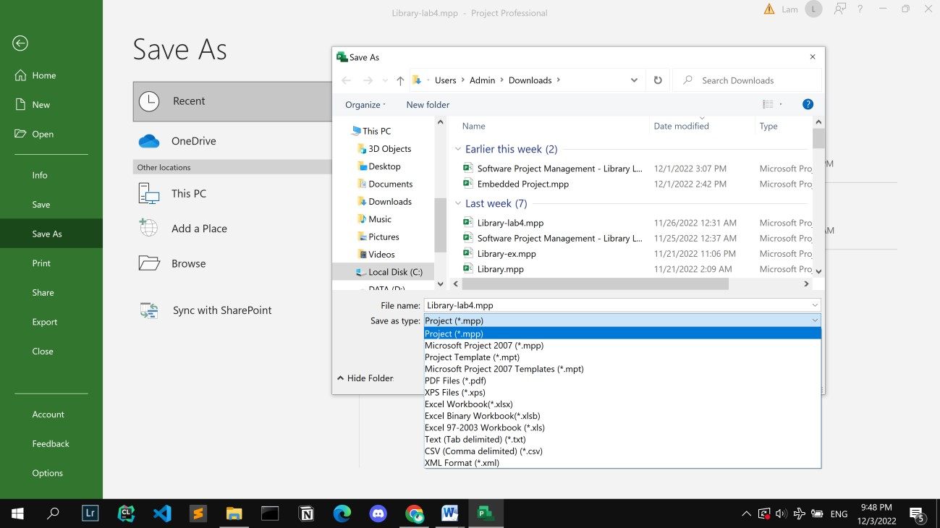

1. Make reports that represent summarization, meeting, progress, experience drawn from the project.

**Overall:**

In general, our project is summarized like this:

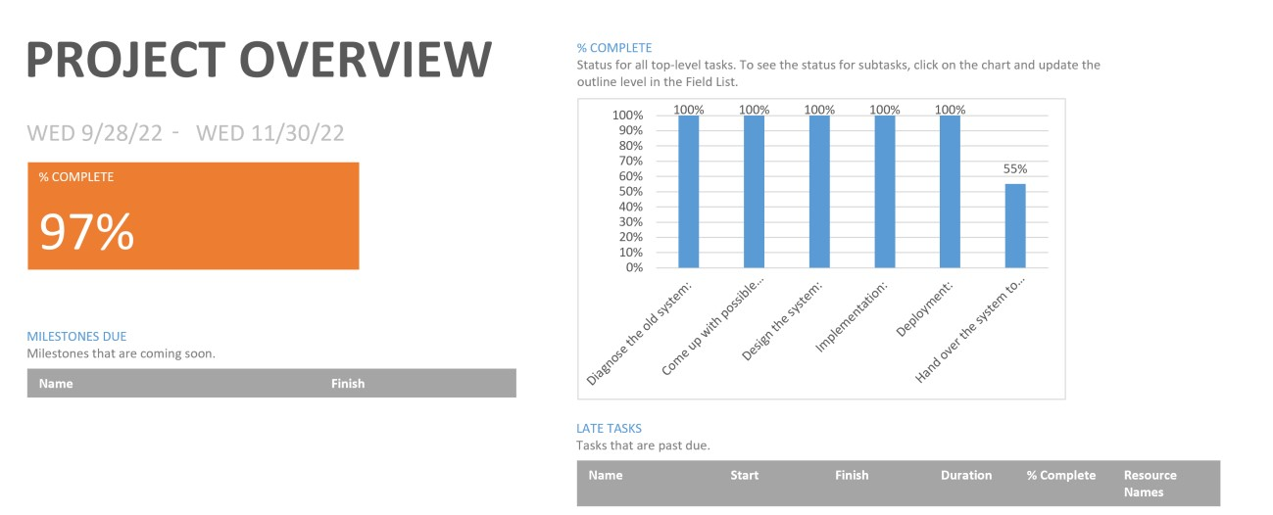

We have some tasks that are done within 8hrs:

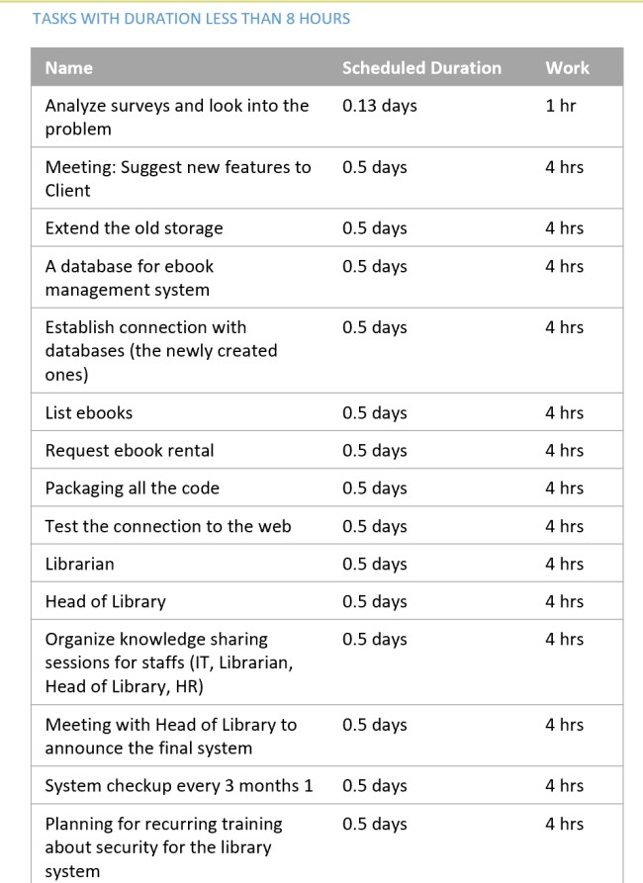

**Progress report:**

We have reports represent slipping task:

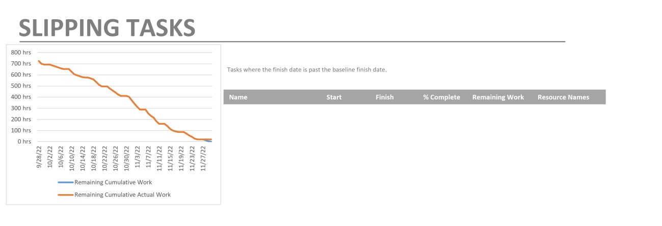

Critical task visio

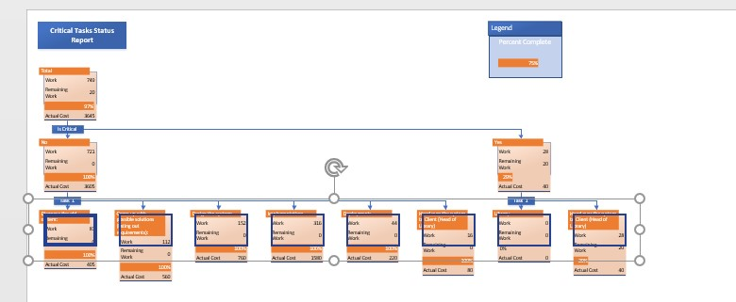

Also we can view the report generated for our milestones: • Milestone report:

